PHY F242 QUANTUM MECH I

ASSIGNMENT-01

Name : PRAGUN NANDA Date Of Assn : 10/02/2020

ID : 2018B5PS0585G Date of Subm : 15/02/2020

**Q** :

Given a 1D electron in a box of length a = 0.1m, the wavefunction is made up of three stationary states defined by n1, n2 and n3. Find the wavefunction of the electron and plot the following :

• Ψ(x, 0) vs x

• Ψ(x, t) vs x for a given time t

• |Ψ(x, 0)|2 vs x

• |Ψ(x, t)|2 vs x

**SOL:**

The wavefunction for electron in nth stationery state is :

$ψ_{n}(x,t)= \sqrt{\frac{2}{a}}\sin\left(\frac{nπx}{a}\right)e^{-\frac{iE_{n}t}{ℏ}}$; $E_{n}=\frac{n^{2}π^{2}ℏ^{2}}{2ma}$

Where, En = energy associated with nth state

a = length of the box = 0.1m

m = mass of electron = 9.109 x 10-31kg

ħ = (modified) Planck’s constant = 1.054 x 10-34 J.s

General expression for wavefunction of *k* (here, k =3) number of stationery states is :

$ψ_{n}(x,t)= \sum_{k=1}^{3}{c_{k}}\sqrt{\frac{2}{a}}sin⁡(\frac{n_{k}πx}{a})e^{-\frac{iE_{n_{k}}t}{ℏ}}$

Where, *ck ϵ c (constant).*

Now, we know that for the set of coefficients {c1, c2, c3},

Assuming that coefficients are equal, i.e. c1 = c2 = c3 = c (say), we get

|c|2+|c|2+|c|2 = 1

3|c|2 = 1

Assuming that *c ϵ r (real)* , we get $c=\frac{1}{\sqrt{3}}$.

Given: n1 = 14, n2 = 12, n3 = 17 the 14th,12th and 17th stationery states are:

$ψ_{14}(x,t)= \sqrt{20}\sin\left(140πx\right)e^{- \frac{iE_{14}t}{ℏ}}$; $E_{14}=\frac{980 π^{2}ℏ^{2}}{m}$

$ψ_{12}(x,t)= \sqrt{20}\sin\left(120πx\right)e^{- \frac{iE_{12}t}{ℏ}}$; $E_{12}=\frac{720 π^{2}ℏ^{2}}{m}$

$ψ_{17}(x,t)= \sqrt{20}\sin\left(170πx\right)e^{- \frac{iE_{17}t}{ℏ}}$; $E_{17}=\frac{1445 π^{2}ℏ^{2}}{m}$

Thus,



$ψ\left(x,0\right)=\frac{1}{\sqrt{3}}(\sqrt{20}\sin\left(140πx\right)+\sqrt{20}\sin\left(120πx\right)+\sqrt{20}\sin\left(170πx\right))$

$ψ\left(x,t\right)=\frac{1}{\sqrt{3}}Re[\sqrt{20}\sin\left(140πx\right)e^{- \frac{iE_{14}t}{ℏ}}+\sqrt{20}\sin\left(120πx\right)e^{- \frac{iE_{12}t}{ℏ}}+ \sqrt{20}\sin\left(170πx\right)e^{- \frac{iE_{17}t}{ℏ}} ]$

(For $ψ\left(x,t\right)$, only the real part of the wavefunction has been considered for plotting.)

${|ψ\left(x,0\right)|}^{2}=\frac{20}{3}{(\sin\left(140πx\right)+\sin\left(120πx\right)+\sin\left(170πx\right))}^{2}$

${|ψ\left(x,t\right)|}^{2}=\frac{20}{3}Re{[\sin\left(140πx\right)e^{- \frac{iE_{14}t}{ℏ}}+\sin\left(120πx\right)e^{- \frac{iE_{12}t}{ℏ}}+\sin\left(170πx\right)e^{- \frac{iE_{17}t}{ℏ}} ]}^{2}$

The wavefunctions were plotted using MATLAB, and the following were obtained.

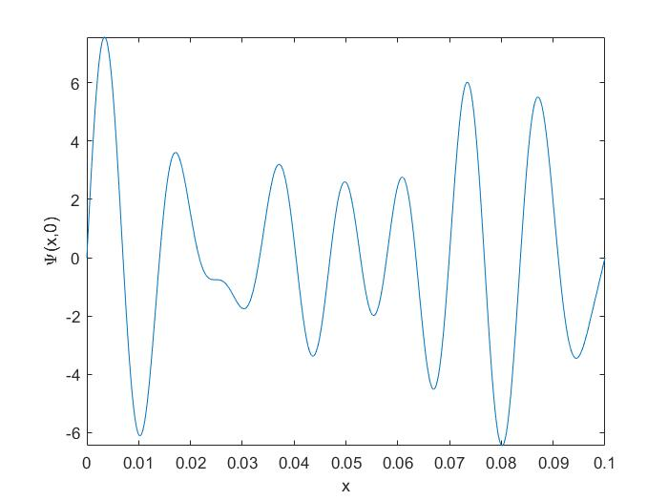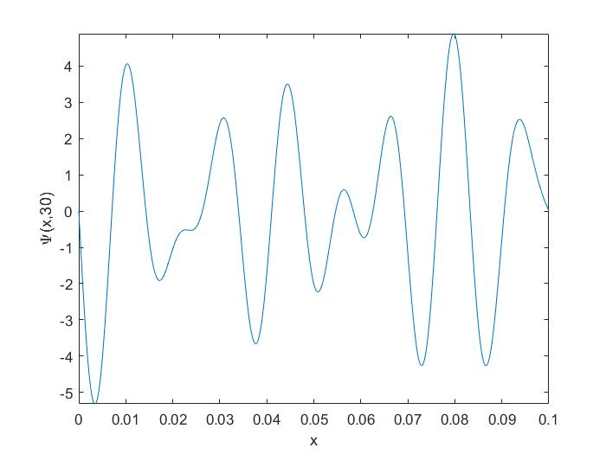

**Ψ(x, 0) vs x Ψ(x, t) vs x, for t = 30s**

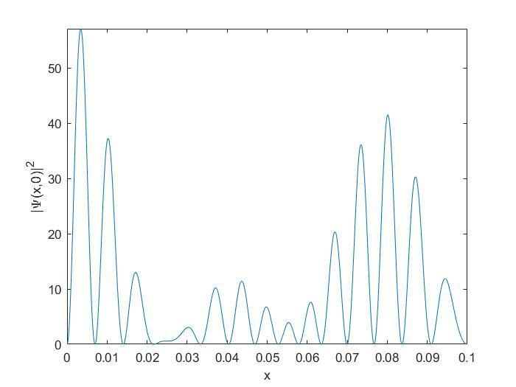 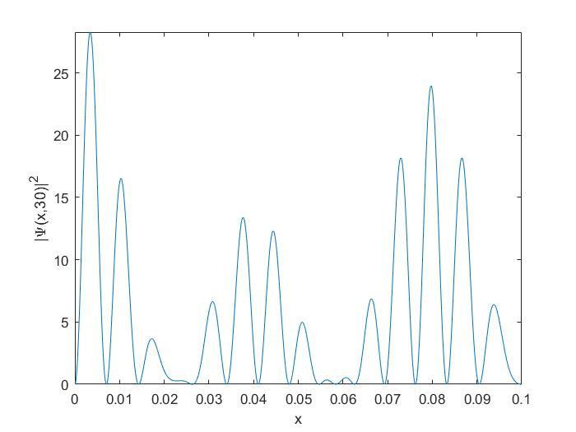

**|Ψ(x, 0)|2 vs x |Ψ(x, t)|2 vs x, for t = 30s**

APPENDIX

MATLAB code :

1. x = 0:0.001:0.1;
2. a=0.1; %length of the box
3. m=9.102*10^-31; %mass of electron
4. hbar = (6.602*10^-34)/(2*pi); %Planck's constant
5. syms psi(x,t) %create a function psi(x,t)
6. psi(x,t) = sqrt(1/3)*sqrt(2/a)*sin(14*pi*x/a)*exp((-i*(14^2)*(pi^2)*hbar*t) /(2*m*a^2))) + sqrt(1/3)*sqrt(2/a)*sin(12*pi*x/a)*exp((-i*(122^2)*(pi^2) *hbar*t)/(2*m*(a^2))) + sqrt(1/3)*sqrt(2/a)*sin(17*pi*x/a)*exp((-i*(17^2) *(pi^2)*hbar*t)/(2*m*(a^2))); %define psi
7. fplot (psi(x,0), [0 0.1]), xlabel('x'), ylabel('\Psi(x,0)')

%plot psi(x,t) vs x for diff values of t; add axis labels

1. fplot (real(psi(x,30)), [0 0.1]), xlabel('x'), ylabel('\Psi(x,30)')
2. fplot (abs(psi(x,0))^2, [0 0.1]), xlabel('x'), ylabel('|\Psi(x,0)|^{2}')
3. fplot (abs(real(psi(x,30)))^2, [0 0.1]), xlabel('x'), ylabel('|\Psi(x,30)|^{2}')